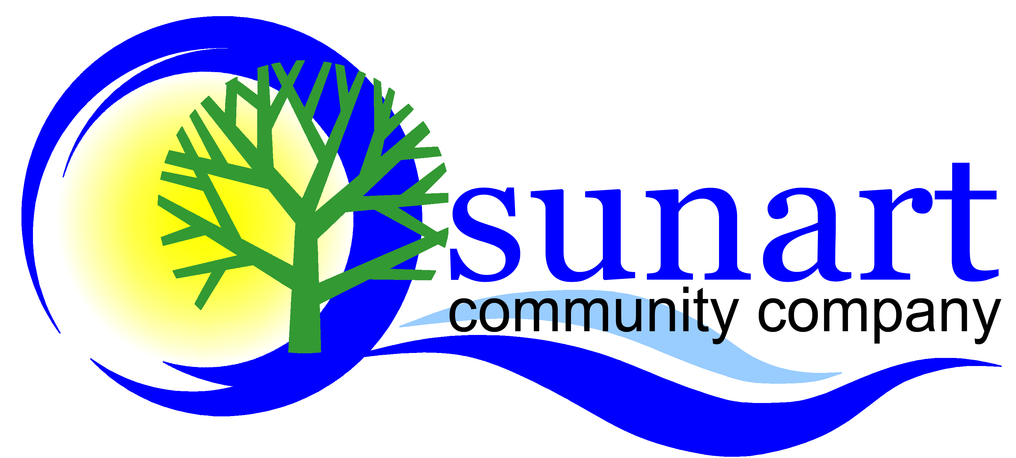
SUNART COMMUNITY COMPANY
Application for Membership (Free!)
I wish to apply for membership of the Sunart Community Company and can confirm that I support their aims and objectives as outlined in the Memorandum & Articles of Association.
Please enrol me in the following membership category, (please tick one):
Full Membership I am resident within the Sunart catchment area and I am aged 16 years or over. I am entitled to vote at local government elections in the area.
Junior Membership I am resident within the Sunart catchment area and I am aged between 12 and 15 years.
Associate Membership I am not resident within the Sunart catchment area. I am aged 16 years or over.
I understand that membership is FREE and in the event of the Company being wound up, my liability will be limited to a maximum of £1 (one pound).

Full Name:…………………………………………………………………………………....................................
Address :.................................………………......…………………………………….…………………………..
………………………………………………………………………………………………………………………………………
Postcode:…..…………………………… Date of Birth (Junior Members only) ...........................

Email address:……………………………………………………….………………………………………………………
(We will not share your email with anyone else but will occasionally update you on community initiatives and the work of the Company.)

Tel No (optional):……..……………………………………………… Date: ……………………………………………

Signature: …………………………….……………………........................................................................
Please return your completed application to the address below. Full members are entitled to elect and be elected as Directors. All members will receive regular updates and are welcome to comment on, support and get involved in our activities.
Thank you for your interest in joining the Sunart Community Company
Sunart Community Company
Registered Charity No. SC039640; Company No. SC293485
Registered Office: Creag Ard, 5 Longrigg Road, Strontian, Acharacle, PH36 4HY

